Section 3 – Design
Introduction:
In this section, I will start planning the actual development for El Aziz’s restaurant system. I will create a range of data structure tables, entity relationship diagrams, structure diagrams, and designs for the UX of the GUI. This will help me be more prepared for the development of the program and allow me to ensure each of my aims and objectives are met, aligning with El Aziz's needs.

Data Structure Diagrams:
I have decided to split my structure diagram into three separate sections for each of the stakeholders, for better and clearer presentation.
Customer:
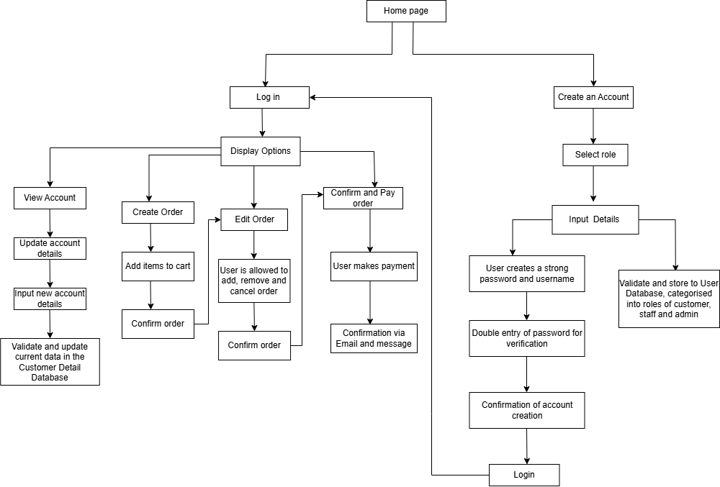

Ultimately, the customers should be displayed on the home page of El Aziz first. This aligns with the need for functional UX, as the home page can show images of cuisine and provide contact information and anything else on the front screen. It allows El Aziz to make a good first impression on customers, engaging them. Then they will be prompted to either create an account or login. This aligns with my objective of data security of the system. By creating an account, all stakeholders and users will have their data safely stored in a secure database via SQLite. Validation and verification will prevent unauthorised access, enhancing the safety of the system. Giving users clear and several options makes it more interactive and user friendly. By providing clear subheadings for tasks to complete, with boxes, and clicks, it makes it easier to navigate, enhancing its functionality and efficiency. Customers being allowed to update their own account details reduces the workload for admin. This structure diagram demonstrates functionality, procedural task completion and data security, which meet my aims and objectives.
Staff:
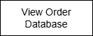
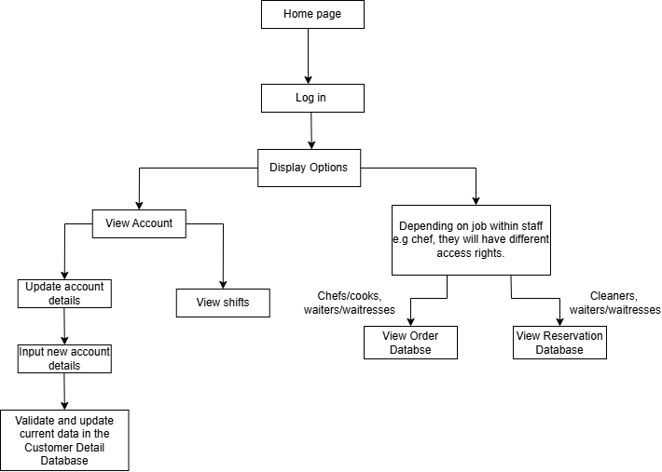

Essentially, the staff members should be displayed on the home page of El Aziz first, as a starting point. Then they will be prompted to login as when they had started working, they would’ve been made an account already by the admin. This aligns with my objective of data security of the system. This ensures that staff data is safely stored in a secure database via SQLite. Validation and verification will prevent unauthorised access, enhancing the safety of the system. Giving staff members clear and several options makes it easier to navigate. They will be presented with tasks like viewing their account to access their shifts. They will also be able to view specific databases depending on their access rights. For staff like chefs, cooks, waiters and waitresses, they would be able to view the order database. Cleaners, waiters and waitresses will be able to view the reservation database. Staff will be allowed to update their own account details, reducing the workload for admin. This structure diagram demonstrates functionality and prioritises data security, effectively meeting my objective.
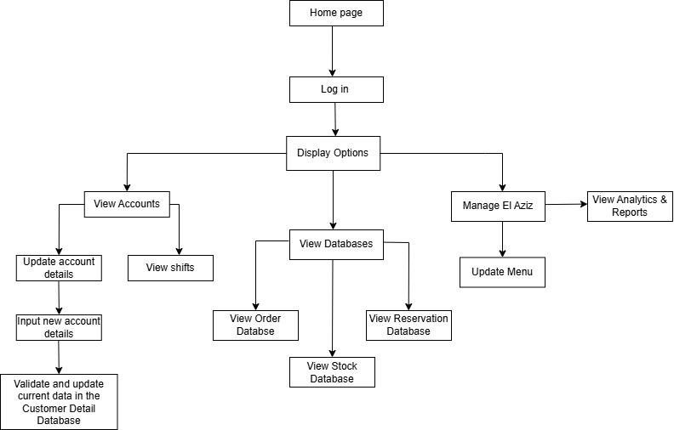
Admin:

Basically, the admin will be taken to the home page of El Aziz first, as a starting point. This way they can view the webpage from the perspective of any other use, to observe any need for development. Then they will be prompted to login to prevent unauthorised access and display different controls. This aligns with my objective of data security of the system. This ensures tasks like viewing secure database via SQLite and updating account details can only be executed by the correct authoritative figure. Validation and verification will prevent unauthorised access, enhancing the safety of the system. Giving the admin clear and several options makes it easier to navigate. They will be presented with tasks like viewing all staff accounts to access their shifts, as well as viewing customer accounts in case there are any technical issues to be handled. They will also be able to view all databases, including the stock database. In case, any items or ingredients run out or are running low, the system will notify the admin to order new stock. The admin will have full access to all data and databases. This structure diagram demonstrates functionality and prioritises data security, effectively meeting my objective.
Data Dictionary:
Customer Data Table:
Field Name | Data Type | Length | Default Value | Validation | Sample Data | Method Of Access
CustomerID  (Primary Key) | String | 5 | - | Presence check. | “N3S01” | Serial
firstName | String | 30 | - | Length check- must not exceed 30 characters. | “Neslihan”
surname | String | 30 | - | Length check- must not exceed 30 characters. | “Hazrat”
dateOfBirth | Date | 8 | - | Presence check. Format check – DD/MM/YYYY | “29/12/2006”
emailAddress | String | 50 | - | Format check- must contain ‘@’ and ‘.’.  Presence check. | “neshazrat@gmail.com”
phoneNum | Integer | 11 | - | Type check- Integers.  Format check- must be 11 digits including the +998. | “+998 93-932-88-99”
postcode | Integer | 6 | - | Presence check.  Type check- Integers  Format check- 6 digits | “100163”
streetName | String | 60 | - | Presence check | “Mustaqilik Avenue, No. 23”
gender | Char | 1 | - | Length Check – 1 character | “F”
username | String | 25 | - | Length check – 25  Presence check | “neshazratx”
password | String | 25 | - | Length check – 25  Presence check | “Password123”
Staff Data Table:
Field Name | Data Type | Length | Default Value | Validation | Sample Data | Method Of Access
StaffID (Primary Key) | String | 5 | - | Presence check. | “M2100” | Sequential
firstName | String | 30 | - | Length check- must not exceed 30 characters. | “Mehribon”
surname | String | 30 | - | Length check- must not exceed 30 characters. | “Hazrat”
dateOfBirth | Date | 9 | - | Format check – DD/MM/YYYY | “17/02/1999”
emailAddress | String | 50 | - | Format check- must contain ‘@’ and ‘.’.  Presence check. | “mehrhazrat@gmail.com”
phoneNum | Integer | 11 | - | Type check- Integers.  Format check- must be 11 digits including the +998. | “+998 93-972-82-99”
postcode | Integer | 6 | - | Presence check.  Type check- Integers  Format check- must be 6 digits | “100163”
streetName | String | 60 | - | Presence check | “Mustaqilik Avenue, No. 32”
hireDate | Date | 9 | - | Type check – Integers  Format check- DD/MM/YYYY | “03/12/2018”
position | String | 30 | - | Presence check. | “Chef”
salary | Real | 50,000 | - | Type check – Real  Range check - >0 and <50000. | “22,000.00”
status | String | 30 | - | Presence check  Format check – Active/Inactive | “Active”
workSchedule | String | 60 | - | Presence check | “Mon-Fri, 9-5”
gender | Char | 1 | - | Length Check – 1 character | “F”

Admin Data Table:
Field Name | Data Type | Length | Default Value | Validation | Sample Data | Method Of Access
AdminID  (Primary Key) | String | 5 | - | Presence check. | “A4S07” | Direct
firstName | String | 30 | - | Length check- must not exceed 30 characters. | “Abdulla”
surname | String | 30 | - | Length check- must not exceed 30 characters. | “Khusanov”
dateOfBirth | Date | 8 | - | Presence check. Format check – DD/MM/YYYY | “21/08/2008”
emailAddress | String | 50 | - | Format check- must contain ‘@’ and ‘.’.  Presence check. | “akhusanov@gmail.com”
phoneNum | Integer | 11 | - | Type check- Integers.  Format check- must be 11 digits including the +998. | “+998 97-981-82-34”
postcode | Integer | 6 | - | Presence check.  Type check- Integers  Format check- must be 6 digits | “102123”
streetName | String | 60 | - | Presence check | “Yunusobod Avenue, No. 23”
accessLevel | String | 15 | Full | Presence check | “Full”

Order Data Table:
Field Name | Data Type | Length | Default Value | Validation | Sample Data | Method Of Access
OrderID  (Primary Key) | Integer | 5 | - | Presence check. | “00001” | Sequential
CustomerID  (Foreign Key) | String | 30 | - | Presence check | “N3S01”
orderDate | Date | 9 | - | Presence check. Format check – DD/MM/YYYY | “01/11/2025”
orderTime | Time | 4 | - | Format Check – HH:MM
menuItem | String | 40 | - | Presence Check | “21/08/2008”
quantity | Integer | - | - | Type check - Integer | “2”
totalPrice | Real | 5 | - | Type check – Real  Range check- >0 and <999.99 | “$23.69”
orderStatus | String | 6 | - | Presence check | “Pending”
dietaryRequirement | String | - | - | Type check – String | “Halal”
Reservation Data Table:
Field Name | Data Type | Length | Default Value | Validation | Sample Data | Method Of Access
ReservationID  (Primary Key) | Integer | 5 | - | Presence check. | “10001” | Indexed Sequential
CustomerID  (Foreign Key) | String | 30 | - | Presence check | “N3S01”
reservationDate | Date | 9 | - | Presence check. Format check – DD/MM/YYYY | “01/11/2025”
reservationTime | Time | 4 | - | Presence check  Format Check – HH:MM | “19:30”
tableNumber | Integer | 3 | - | Presence Check  Type check – Integer  Range check - <0 and >100 | “12”
numOfGuests | Integer | 2 | - | Type check – Integer  Range check - <0 and >50 | “4”
specialRequest | String | 150 | - | Presence check | “Window Seat”
Stock Data Table:
Field Name | Data Type | Length | Default Value | Validation | Sample Data | Method Of Access
StockID  (Primary Key) | Integer | 5 | - | Presence check. | “70001” | Indexed Sequential
itemName | String | 40 | - | Presence check | “Olive Oil”
quantityAvailable | Integer | 4 | 0 | Range check - >0  Type check - Integer | “15”
reorderLevel | Integer | 4 | 5 | Range check - >0  Type check - Integer | “5”
unitPrice | Real | 6 | 0.00 | Type check - Real | “$4.25”
supplierName | String | 50 | - | Presence check | “Qarshi – Foods”

Login Data Table:
Field Name | Data Type | Length | Default Value | Validation | Sample Data | Method Of Access
Time | Time | 5 | - | Format check- HH:MM | “16:49” | Serial
Date | Date | 10 | - | Format check – DD/MM/YYYY | “21/08/2005”
Username | String | 25 | - | Presence check | “neshazratx”
Password | String | 25 | - | Presence check | “password”

Menu Data Table:
Field Name | Data Type | Length | Default Value | Validation | Sample Data | Method Of Access
MenuItemID  (Primary Key) | Integer | 5 | - | Presence check. | “70001”
itemName | String | 40 | - | Presence check | “Samsa”
itemAvailability | String | 10 | Available | Format check -Available/Out of Stock | “15”
itemCategory | String | 20 | - | Format check – Starter/Main/Dessert/ Drink | “5”
itemPrice | Real | 6 | 0.00 | Type check - Real | “$10.79”
itemDescription | String | 50 | - | None | “Traditional Uzbek Samsa containing meat and onion”
preperationTime | Integer | 3 | - | Range check - > 0 and < 60 minutes | “20 minutes”
Payment Data Table:
Field Name | Data Type | Length | Default Value | Validation | Sample Data | Method Of Access
PaymentID  (Primary Key) | Integer | 5 | - | Presence check. | “90001” | Direct
OrderID  (Foreign Key) | Integer | 5 | - | Presence check | “00001”
CustomerID  (Foreign Key) | String | 5 | - | Presence Check | “N3S01”
paymentDate | Date | 10 | - | Format check – DD/MM/YYYY | “5”
amountPaid | Real | 7 | 0.00 | Type check – Real  Range check – must equal totalPrice | “$10.79”
paymentMethod | String | 15 | - | Format check – Cash/Card/Contactless | “Contactless”
paymentStatus | String | 15 | - | Format check – Pending/Paid/Refunded | “Pending”
Analytics & Reports Data Table:
Field Name | Data Type | Length | Default Value | Validation | Sample Data | Method Of Access
ReportID  (Primary Key) | Integer | 5 | - | Presence check. | “97001” | Indexed Sequential
reportType | Integer | 5 | - | Presence check  Format check – Daily Sales /Monthly Revenue/ Top Menu Items/ Staff Hours / Customer Reservations | “Monthly Revenue”
dateGenerated | String | 5 | - | Presence Check | “01/11/2025”
totalSales | Real | 10 | 0.00 | Range check – >0. | “$4275.40”
totalOrders | Integer | 5 | 0 | Range check – >0. | “183”
mostPopularItem | String | 40 | - | None | “Pilaf”
startDate | Date | 10 | - | Format Check – DD/MM/YYYY | “01/10/2025”
endDate | Date | 10 | - | Format Check – DD/MM/YYYY | “31/10/2025”
Shifts Data Table:
Field Name | Data Type | Length | Default Value | Validation | Sample Data | Method Of Access
startTime | Time | 5 | - | Format check- HH:MM | “05:00” | Indexed Sequential
endTime | Time | 5 | - | Format check- HH:MM | “11:00”
Hours | Integer | 2 | 0 | Type, presence check. | “6”
Date | Date | 10 | - | Format check – DD/MM/YYYY | “20/11/2025”
StaffID | String | 5 | - | Presence check | “M2100”
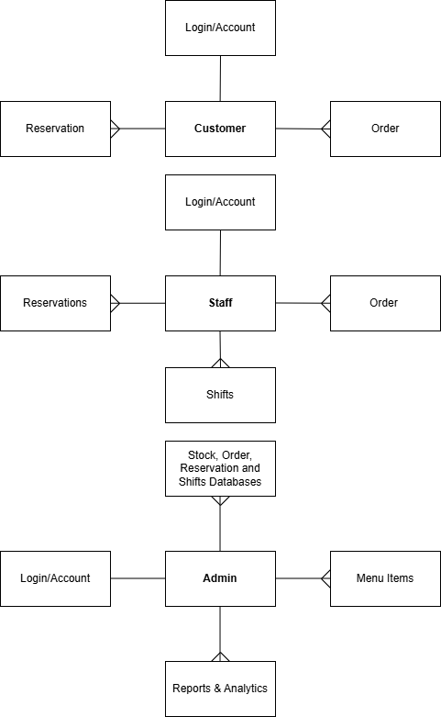
Entity Relationship Diagrams:

Looking at the entity relationship diagram I have drawn above, it is clear to see the relationships between tables for customers, staff and admin. Ultimately, a customer can create multiple orders and reservations. This notion resulted in a one-to-many relationship between the customer and order table as well as the customer and reservation table. A single customer will have one login and account, indicating a one-to-one relationship. The login table will include fields of their username, password, time and date of login for security purposes. I have avoided the use of many-to-many relationships as it can complicate the system and its data handling. In the customer table, I would include fields such as the: CustomerID (Primary Key), first name, surname, date of birth, email address, phone number and street name.

In the Order table, I would include fields such as: OrderID (Primary Key), CustomerID (Foreign Key), item name, quantity, total price and dietary requirements. For the reservation table I would consider fields like: ReservationID (Primary Key), CustomerID (Foreign Key), table number, reservation date and time, number of guests and special requests. The staff will also share a similar one-to-many relationship between order, reservations and shifts. One staff member can view many reservation, many shifts and many orders. This will allow staff to complete their work efficiently with the help of digital storage of data. I would include similar fields for the order and reservation table however for the staff table I would include fields such as: StaffID (Primary Key), their personal details similar to the customer table, gender, hire date, position, salary, work schedule and status. Staff will also have a one-to-one relationship with logins and accounts. Staff will be able to view many shifts on their schedule. Shift table fields will include the start and end time, staffID, date and hours.
Finally for the Admin, they have multiple one-to-many relationships with the databases, menu items and the reports & analytics. The admin will have access and be able to access multiple resources to maintain the system. Fields for the stock database will contain: StockID (Primary Key), item name, quantity available, reorder level, unit price and supplier name. The fields for the order, reservation and shifts data table will be the same as mentioned in other tables. The admin will be able to manage many menu items, with fields like: menuItemID (Primary Key), item names, availability, price, category, description and preparation time. Finally, an admin can view multiple reports and analytics for research and development. This table will include fields like: reportID (Primary Key), report type, generated date, total sales, orders, most popular item, start and end date.
The Interface:
Home page - ALL:
Clear welcoming, user friendly approach.
Contact us:
elazizservices@gmail.com
+998 93-945-86-91
Welcome to El Aziz!
Contact information provided for customer service.

Select your position/role in the system to trigger your log in or account creation.
Customer
Staff

Admin
A lot of blank space – cleaner and simpler to look at and use.

Large buttons with color make it easier to navigate.

Clear welcoming, user friendly approach.
Welcome to El Aziz!
Large buttons with color make it easier to navigate.

Sign Up
Login
A lot of blank space – simpler user interface. Doesn’t overwhelm the user.
Different output screens depending on the option they choose.
Options to sign up or log in – tailored to customer preference, considering all possibilities.

Login/Sign up – ALL:
Possibly encrypt the password entered as a security measure.
Log in

Username:

Password:

Requires entry of username and password to prevent unauthorised access – data security measures.

Verification checks put in place to ensure data is consistent. If password is incorrect, prompted to try again.
Clean and simple interface – not too cluttered

Validation checks in place to ensure data is possible in order to successfully sign up.
Requires entry of information like legal name, email address, etc. in order to successfully create an account.
Sign up

First Name:

Surname:

Password:

Password:

Phone Number:

Email Address:

Phone Number:

Double entry ensures verification. Password must be consistent in order to proceed with account creation.

Task Viewing - CUSTOMER:
Large buttons to click to proceed with task of interest – Tkinter.
Clear heading to tell user what this page is.
4. Confirm and Pay
3. Edit Order
- Create Order
- Make reservation
Options:

Clean and tidy organisation of list. Easy for user to use and is clear to understand.
List of tasks in order based on the access levels and operations as a customer.

5. View Account

Task Viewing - STAFF:
Large buttons to click to proceed with task of interest – Tkinter.
Clear heading to tell user what this page is.
Options:
2. View Shifts
- View Account
3. View Databases

Clean and tidy organisation of list. Easy for user to use and is clear to understand.
List of tasks in order based on the access levels and operations as a member of staff.

Task Viewing - ADMIN:
Clear heading to tell user what this page is.
Large buttons to click to proceed with task of interest – Tkinter.
- View Accounts
2. View Shifts
3. View Databases
4. Manage Menu
5. View Reports/ Analytics
Options:

Clean and tidy organisation of list. Easy for user to use and is clear to understand.

List of tasks in order based on the access levels and operations as an admin.

Make Reservation - CUSTOMER:
- Make reservation
Clear heading to tell user what this page is.
Full Name:

Phone Number:

Reservation Time:

Special Requests:

Email Address:

Reservation Date:

Number of Guests:

Fields require to successfully make a reservation.

Simple and clear user interface.

Confirm

All data entered is processed before being store to the Reservation Database, under the ReservationID they have been assigned.
Confirm button to click to proceed with task and finalise data entered – Tkinter.
Create Order - CUSTOMER:
Browse Menu:

Clear heading to tell user this is the menu.
Choi
Kompot
Soda
Water
Salad
Non
Drinks:
Sides:
Shashlik
Samsa
Pilaf
Jizz
Main:
Menu:

Subheadings to categorise the items to purchase/ add to order.

Clear and readable text making it easy for customers to understand and think about.

Menu is only for browsing and looking at, the menu items if clicked on will not be added to order, that is a separate process.

Once you press on an item, the item description, availability and cost will be displayed on a separate tab.

Making Order:
Small arrow demonstrates a drop-down menu, showing all items off the menu. Intuitive and user friendly.
Clear subheading informing user of current process.
Create Order

Confirm
+ Add Item
Item:

Quantity:

Dietary Requirements:

All 3 fields must be completed to successfully add an item to order.
Opportunity to customise order by specifying quantity and any dietary requirements of customer.

Add another item to repeat the process, selecting a different item to your order while specifying the quantity wanted and alerting of any dietary requirements.
Confirm to proceed to next task.

Allows customer to edit orders by removing, changing or adding an item.
Edit Order
Current Order:
Similar user interface, with a new addition to remove an item to edit the order.
Dietary Requirements:

Quantity:

Item:

Confirm once order is finalised.
+ Add Item
- Remove Item
Confirm

Confirming and Paying:
Algorithm will successfully calculate the total cost of order by adding up individual costs of items.
Total:

Pay Now
Payment: Method:

Total:

Your Order:

Clear subheading- YOUR order.

Items: (including quantity)

List of order items (order summary)
Dietary requirements:

Selection of payment methods via drop down menu.

Large button, clear text. Click to successfully make payment.

Receipt Confirmation:
List of order items, essentially an order summary.
Order no: 00001
Assigns the customer an order number – easier to store order and retrieve.
Items: (including quantity)

Dietary requirements:

Plain interface – easy to read.
Displays the total of customer order.

Viewing Accounts - ALL:
Clear heading informing user of their account details.
Grey boxes will display their details.

Surname:

First Name: Total:

Your Account:

E.g Neslihan

E.g Hazratqulova

…

… Insinuates the same format for different fields and personal details like email, phone number etc.

Same format/display for all users.

Viewing Shifts – STAFF AND ADMIN:
Monday:
Tuesday:
Wednesday:
Thursday:
Friday:
Saturday:
Sunday:

Clear heading informing staff and admin of their shifts/working hours.
Your Shifts:
List format describing shifts/working hours for staff and admin.

Plain format/style – easy to read and focus on one field.

Admin will be able to view their staff working hours/shifts as well due to full control and access rights.

Viewing Databases – STAFF AND ADMIN:
- Staff will be able to view just the average database/table from SQlite. Very clear to read and understand.
- Easy to search and sort for items as well, making it efficient for staff and admin.
- Live tracking of orders, reservations and stock levels.
- Before viewing the actual database, form the previous menus/options for both staff and admin, they both had the option to ‘view databases’. After they click this they will be taken to another menu giving them the option to view different databases purely based on their access rights.
- Once they click one of the databases, then they will be able to view it.

Viewing Reports/Analytics – ADMIN:
Data representation via graphs, pie charts etc.
Clear heading informing admin of their business’s analytics.
Your Analytics:
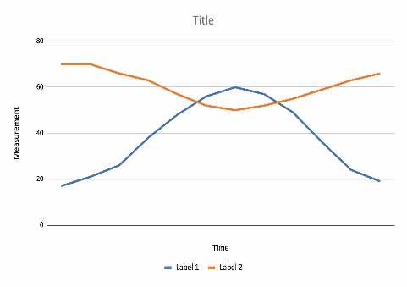
Report Type:

Summary of Data:

Allow admin to specify report type such as: Daily Sales /Monthly Revenue/ Top Menu Items/ Staff Hours / Customer Reservations

Easier to read and immediately focus on.
Summarises and draws conclusion from data in graph, pie chart etc.
Blank space consider UX design factors, easier to read and not too overwhelming.

Inputs and Outputs:
Based on the output screens displaying the graphical user interface of El Aziz’s restaurant system, my designs meet El Aziz’s objectives and requirements. The interface prioritises user experience by considering many features that make user experience inclusive, accessible and easy to navigate. In all output screens above, clear headings are shown near the top to inform the user of the tab/window they are on, in other words, the task they are currently completing. Large font in bold colours has been used to make it readable and more visible, making it easier for users to focus on. I have also avoided crowding of the buttons, icons or drop-down menus to ensure it is clear to navigate and won’t overwhelm the user. I have done this by leaving a lot of blank space to provide a calm user experience.
For the Home Page, I have included a welcome message in bold and big writing as a form of user friendliness. The use of grey makes this stand out. I have also provided contact information for users if they require any assistance or request for extra services. Under this, three large buttons are displayed with the same big writing to ask users to select their role/position when using the system. One simple click will then prompt all users to either sign up or login. This will be on a separate tab/window, asking users to select their option. Data entered to login will consist of a username and password whereas to sign up and create an account, users are expected to enter their first and last name, email address, phone number, and then create their own password. Double entry is used for the password to successfully verify that their data inputted is consistent and that the passwords are the same for both entries. This data will be stored in the customer data table where they will also be assigned a customer ID automatically. The username and login will also be stored to a login data table for maintenance, in case accounts need to be removed or updated, however the user will be able to do this themselves.
For the viewing of tasks, once they have successfully logged in or created an account they will be displayed a list of options/tasks to complete depending on their role/position within El Aziz. As a customer, they will be presented with options to view their accounts, make reservations, create orders, edit orders and successfully make payments. In terms of staff, they will be able to also view their accounts as well as view their shifts and access any databases required for them to operate. The databases provided will depend on their access level. For example, a waiter will have access to the order and reservation database whereas the chef will only have access to the order database. The admin will be displayed several tasks like viewing accounts, managing the menu, viewing stock levels, viewing databases, and accessing the reports & analytics. Ultimately, this provides them full access to manage the El Aziz system. The user interface deigns for these menus have been very considerate of simple UX and enhancing customer experience. Once you click one of the tasks it will take you to complete the task making it intuitive and faster. A lot of blank space and clear text has been used considering the user and making it inclusive for all types of users. To view their shift, they will be displayed a list describing their work hours specifying the hours and date.
As a customer, they have been displayed numerous tasks. I have designed the output screens for all tasks from browsing the menu to confirming a payment. I have followed the same style of user interface designs but to make the ordering process more efficient To browse the menu, users can select or click on one of the items to which they will be displayed the item name, availability, item description and preparation time. The description will inform users of any allergies or dietary requirements. This makes the customer experience more engaging and interactive. I have included the use of drop-down menus when creating an order. How it works is that the user will be taken to the screen where they will select the item name they would like and then they will specify the quantity desired as well as specifying any dietary requirements. Once they have added that item, they can add another item by clicking the button to repeat the process again. The symbols of ‘+’ and ‘-‘make it easier to understand and more inclusive. This helps with any language barriers. To make reservations, customers will be prompted to fill out mandatory fields such as first name, surname, email address, phone number, reservation date and time, special requests and the number of guests. This data will be confirmed and successfully stored in the reservation database using the fields form the reservation data table. From this, customers will be assigned a ReservationID and will store the customer details under the CustomerID as a primary key to save up space and make data handling more efficient. To make a payment, customers will be displayed their order summary displaying the items and quantity as well as noting any dietary requirements (if any). They will then be displayed their total which will be accurately calculated form the addition of the individual items considering the quantity of each item. They will then select their payment method from a drop-down menu, enhancing functionality and proved easy selection. They will then confirm and make their payment. Following their payment, they will be displayed a digital receipt summarising their order and total paid. At the top of this receipt, they will be shown their order number which would’ve been automatically assigned when they created their purchase. The order details will be confirmed and then saved to the order database, considering the data from the order data table.
As a staff member, they will be given the chance to view their account details, shift details and access databases depending on their access level. This was all explained earlier on when discussing the task viewing functions.
As an admin, they will also be provided the tasks of viewing accounts, accessing databases and viewing shifts. However, they will do this on large scale by being able to view all active accounts as well as viewing all employees shifts in case any changes or arrangements need to be made. The admin will also oversee the menu by making any changes to items on the menu by adding or removing items and updating item availability. They will also be able to view all active databases for the system such as the order, reservation, stock level, and payments databases. In the order database they will view the item names and quantities of each item in a customer’s order as well as the total cost. In the reservation database, they will view the customer id, reservation id, reservation date, time, and number of guests. If any special requests have been made, they will be able to see this too. For the stock level database, they will be able to see the item name, availability, suppliers, reorder level, and unit price. This will allow admins to make logical decisions and order more stock if current stock items are low on availability when high in demand. For the payments database they will view the customer ID, orderID, total paid and the status of the payment. Admins will also be able to view their analytics by selecting the option to view their reports and analytics. They will be able to select the report type such as ‘Monthly revenue’ Here they will be shown some form of data representation like a line graph, showing their business growth. It will also summarise the findings making it easier to focus on. This allows admins to view their business credentials and make any improvements to enhance their business.
Data Structure & Validation:
Data Structures & Files used
For El Azizs restaurant system, I have chosen to use multiple different methods of access depending on the tasks to complete and the data required to be stored. I intend on storing all data in databases for safe storage. Based on this judgement, I aim to make the data storage and transfer as quick and efficient as possible.
In terms of the Customer table, I have chosen to use the serial method of access. This was mainly due to the fact that this table contained a primary key of the ‘CustomerID’. Using this primary key, I understand that the records won't have to be stored in order and will mainly be appended or checked in the order they are created, and does not require sorting. Serial access was the best choice because new customers can be added easily and no sorting is required. As the customer will complete tasks like creating accounts, making orders and reservation, editing their orders and confirming and paying, I thought that serial access allowed for the data to be added or deleted safely and fast. With the use of a serial method, this allows me to implement a linear search into the program to search for the customerID. The customerID will be used to make reservations, becoming a foreign key in the reservation table. Additionally, this method of access will store the customer data such as their name, email address etc. to a customer file. This customer file will store all customer records in a single database table, and the program will access the data using linear search algorithms to locate a CustomerID and update or insert new records by appending them safely to the end of the file.
For the Staff table, I decided to use the sequential access method, because it would allow for the organisation of staff based on their roles and staffID. The staffID will differ depending on different roles however, different people working as the same role will have the same starter for their ID. Using this notion, I understood that storing the staff records permanently in sorted order by role makes the file suitable for sequential access. By this I mean that storing all the staff members that work as chefs first, then cleaners, then waiters and waitresses etc in order would make it easier to search for as they could just scroll and locate the role/position the staff member is in. Ultimately, I could sort the data based on their role. For this, implementing a binary search would be efficient as the records would already be stored in key order making it easier to search for and retrieve. Additionally, the method of access will store the staff data to a staff file. This staff file will contain all staff records stored in sorted order by role and StaffID, allowing the program to perform fast binary searches on the sequentially organised file and update data by reorganising and rewriting records in the correct order.
Moving on, I chose to use direct access for the Admin. When designing El Aziz’s restaurant system, I considered the scale of their business. Currently, they are a busy small-scale business that is expected to grow into a large-scale business and intending on opening chains elsewhere in Uzbekistan. However, El Aziz informed of their financial status and would like to produce the system on a lower budget. Considering their objectives and goals, I decided to design their system containing the use of only one admin, and because the Admin table is small and requires fast retrieval, I have decided to use direct access. The use of direct access means that I can directly access the databases quickly and easily. This simplifies the process of retrieval and searching for data, which aligns with my client's objectives of simplifying the searching process. For the use of direct access, I will store the required data for the admin table using SQLite, for the rapid access of data. This admin file will be stored as a single-record database table, and the program will use direct key-based lookups to immediately access or update the admin’s details without scanning the rest of the database.
In terms of the order table, I have decided to use the sequential method of access. Due to the use of the OrderID being assigned to orders, storing the orders in OrderID sequence makes them suitable for sequential access and fast binary searching. This will not only make it fairer to the customers, but it will make the file structure efficient for searching and batch processing. By completing the orders one by one, the staff's workload can be less overwhelming and more productive. With the use of a sequential method of access, their also comes the use of a binary search. For customers to search their orders and track their order status live, they can input their orderID and a binary search will be able to search for the orderID in a list of ordered orders. This will be done quickly and effectively, aligning with my objectives. This order file will keep all orders stored in sequential OrderID order, enabling the program to access the file with binary search and process new orders by inserting them into the ordered structure and retrieving data efficiently for order tracking.
For the reservation table, I have considered what method of access would be suitable. Initially, I was considering a serial method of access allowing the reservations to simply be removed or appended form the end of the list of records. However, I realised that this could be messy and unorganised. Instead, I opted to use the indexed sequential method of access. Ultimately, reservations will be assigned a reservationID but what also comes with that is the date and time for their reservation. As there are two key pieces of data to identify a customer's reservation, using an indexed sequential access method where the record is split into two components of a record key and pointer (index) and the bulk of the index stored elsewhere on the disk, seemed fitting to the situation. Therefore, the index will contain the reservationID as the record key and the pointer directing the program to the physical location of the reservation record booking to help tailor the search to locate the exact file or data. The use of this method ensures for chronological order of data stored and will be quicker to update as only the indexes would need to be copied. This reservation file will consist of a sorted main table with a supporting index file that maps ReservationIDs to date and time pointers, allowing the program to quickly navigate the index to locate, insert, or update reservations without scanning all records.
For the stock table, I decided to use an indexed sequential method of access. I chose this because the stock table contains a StockID and so when the admin will check the stock levels, I wanted the order of stock items to be displayed in order of priority, therefore items with lower stock levels would be displayed first. Using an indexed sequential method of access allows the stock levels to be sorted in this order and the index provided enable fast and direct access to records without scanning the whole file. This means it quicker retrieval speeds of data which will be useful for the restaurant at busy times when the demand for items are high. This stock file will include a main table sorted by stock priority and an index that enables fast key-based lookup, allowing the program to quickly update stock levels and retrieve low-stock items using index-driven search algorithms.
For the menu table, I decided to use the sequential method of access. Due to the menu items being displayed in categories and in a logical order for customers, storing them sequentially allows the system to display the menu efficiently and in a user-friendly format. This will make it easier for customers to browse through the menu, select items, and understand the available options. By storing the menu items in order by category or item name, the program can retrieve the data quickly and present it in an organised way. With the use of a sequential method of access, a binary search can be implemented if needed, like for filtering items by category or searching for a specific menu item. This will allow the program to locate the required menu item quickly without scanning the entire list. This menu file will keep all menu items stored in sequential order by category and/or name, enabling the program to access the file efficiently with binary search algorithms and update items when necessary.
In terms of the login table, I chose to use a serial method of access as the login activity entries would be stored in order of arrival, making it easier to view the activity of accounts. It would be easier to view who logged on and off the platform in order from earlier to later times. This would enhance the security of my system, aligning with the goals of El Aziz. This login file will append each login event to the end of the table in serial form, and the program will access the data using simple linear traversal algorithms to review account activity chronologically.
The payment table will use direct access as it will be frequently checked and monitored. In a restaurant that is fast paced, viewing the payments quickly will ensure that it can be viewed by the kitchen to start preparing their order. The system must retrieve a single payment quickly for refunds, receipts, checking order status and verifying orders. With processes like this, direct access is most suitable as it allows quick and specific access without scanning the entire file. This payment file will store each payment record with a unique PaymentID, allowing the program to instantly retrieve or update the record using direct key-based access without scanning the entire table.
Furthermore, the reports and analytics table will use an indexed sequential method of access because it allows for the records to be stored in sorted order, which will be by date. It will also be more fast and efficient with reading the files because analytic and report systems often process all records. As my interface designed for the reports and analytics screen shows how we can filter the data, by making selections, I thought using indexed sequential access methods would be good because it would support grouped and filtered data and sort the fields like the date, category etc. It will be able to search by specific fields making it easier for evaluation and developing solutions to improve the business. This reports and analytics file will store data in a sorted structure supported by indexes, enabling the program to run fast filtered searches and aggregate calculations across the indexed fields for efficient business analysis.
Finally, the shifts data table will also use a direct method of access because it will allow shifts to be directly accessed by the staff or admin member. It simplifies the searching and sorting of these records, making the system more efficient and faster. It allows the system to retrieve specific shift records quickly using a unique identifier such as the StaffID. This improves performance and prevents the system from having to search through all records in order, making it ideal for a staff scheduling system where quick and frequent access to individual shifts is required. The interface for the shifts will simply just present the weekly shifts, sorted by date, disclosing the hours and times for the shift. The shifts file will store the shifts of a staff worker organised by their StaffID, containing the start and end time, date, and hours worked.
Validation rules
To ensure that accounts are protected and data is valid, I will implement several validations checks for specific fields during each process a customer, staff or admin intends to complete. In terms of the customer, when creating an account data such as their phone number, email address, first name, last name and their date of birth. All fields for account creation are mandatory and must be completed, therefore they will undergo presence checks, to make sure user input is not null. Other fields may require multiple validation checks. For example, the phone number will go under a format check to validate whether the user’s input contains a ‘@’and ‘.’ symbol alongside the presence check. The mobile phone number will undergo a length check to make sure it is 9 digits long, following Uzbekistan’s phone number regulations. It will also undergo a type check to ensure the user input is an integer and not letters. Fields that are expected to have the data type as a string will contain presence, length and type checks to ensure the user input is present using characters that are within the character limit. Certain fields such as the total cost will require the data type of a real. For this, a type check will be performed to ensure it is in the correct form. It will also undergo a format check which will ensure the total is up to two decimal places and includes the dollar sign.

Processes & Data Relationships:
Processes
- Login using credentials:
  - All passwords for each account must be created, validated and stored in the database.
  - Double entry verification must be prompted when inputting account password.
  - All username and passwords for user accoutns must be stored in their customer database
  - All accounts must be assigned a LoginID to allow for tracking of account activity for security purposes.
  - Must only let user through if the input password matches with their password they created.
- Allow customers to create, edit, pay and confirm orders:
- Customer’s new orders must be added into the database.
- Orders must be validated for item availability and correct input.
- Customers can edit existing orders before confirmation, including changing items, quantity, or special requests.
- Each order must be assigned an OrderID to track and update order status.
- All changes must be stored immediately in the Order table to ensure data consistency.
- Customers can view/track the status of their orders using their OrderID.
- The system must retrieve the relevant order record from the database quickly.
- Updates to order status must be done in real-time.
- Customers must be able to confirm receipt or report issues, updating their record.
- Allow customers to make reservations:
- Customers must be able to make new reservations with details like date, time, and number of people.
- Reservation inputs must be validated to avoid double bookings or invalid dates.
- Each reservation must be assigned a ReservationID for easy tracking.
- Customers can edit or cancel reservations, which updates the Reservation table.
- All reservations must be stored in indexed sequential order to allow fast searching and chronological display.
- Allow viewing of shifts, databases and accounts:
- Staff must be able to access their shift schedule via StaffID.
- The system must retrieve records from the Staff or Shift table.
- All shift data must be read-only for staff to prevent accidental changes.
- Staff can view data relevant to their role like orders.
- Access must be restricted by role permissions
- The system retrieves the record using appropriate methods of access
- Staff can search/filter data or shifts
- Admin can retrieve all staff shifts
- Admin can sort or filter shifts by date, role and member
- Admin can access all accounts from databases
- Admin can view account activity #Admin can monitor security
- Admin can access any database table
- Admin can search, filter or sort data in each table
- Admin can perform updates and maintenance tasks
- Allow admin to manage the menu:
- Admin must be able to add new menu item with name, category, price and description.
- Admin must be able to edit existing menu items to update any fields
- Admin must be allowed to delete menu items
- All menu changes must be stored immediately in the menu table
- Allow admin to view reports and analytics
- Admin can generate reports on sales, orders etc.
- Admin can filter and group data by date, category etc.
- Admin can export the data to support business decisions. (E.g Download as PDF)
Table mapping Fields of Processes
Field Name | Table Name | Processes
customerID | Customer | Login, signup, creating orders, making reservations tracking order status, payments.
firstName | Customer | Managing customers, signing up
surname | Customer | Managing customers, signing up
dateOfBirth | Customer | Managing customers, signing up
emailAddress | Customer | Managing customers, signing up
phoneNum | Customer | Managing customers, signing up
postcode | Customer | Managing customers, signing up
streetName | Customer | Managing customers, signing up
gender | Customer | Managing customers, signing up
username | Customer | Login, signing up
password | Customer | Login, signing up
staffID | Staff | Viewing shifts, viewing databases
firstName | Staff | Viewing shifts, managing staff
surname | Staff | Viewing shifts, managing staff
dateOfBirth | Staff | Managing staff
emailAddress | Staff | Managing staff
phoneNum | Staff | Managing staff
postcode | Staff | Managing staff
streetName | Staff | Managing staff
hireDate | Staff | Managing staff
position | Staff | Viewing shifts, managing staff
salary | Staff | Managing staff
status | Staff | Viewing shifts, managing staff
workSchedule | Staff | Viewing shifts, managing staff
gender | Staff | Viewing shifts, managing staff
adminID | Admin | Admin management, viewing databases, reports & analytics, menu management
firstName | Admin | Managing admin
surname | Admin | Managing admin
dateOfBirth | Admin | Managing admin
emailAddress | Admin | Managing admin
phoneNum | Admin | Managing admin
postcode | Admin | Managing admin
streetName | Admin | Managing admin
accessLevel | Admin | Managing admin, permission
orderID | Order | Creating/editing orders, tracking order status, payments
customerID | Order | Creating/editing orders, tracking order status, payments
orderDate | Order | Creating/editing orders
orderTime | Order | Creating/editing orders
menuItem | Order | Creating/editing orders
quantity | Order | Creating/editing orders
totalPrice | Order | Creating/editing orders, payments
orderStatus | Order | Tracking order status
dietaryRequirement | Order | Creating/editing orders
reservationID | Reservation | Making reservations
customerID | Reservation | Making reservations
reservationDate | Reservation | Making reservations
reservationTime | Reservation | Making reservations
tableNumber | Reservation | Making reservations
numOfGuests | Reservation | Making reservations
specialRequest | Reservation | Making reservations
stockID | Stock | Viewing databases, stock ordering
itemName | Stock | Viewing databases, stock ordering
quantityAvailable | Stock | Viewing databases, stock ordering
reorderLevel | Stock | Viewing databases, stock ordering
unitPrice | Stock | Viewing databases, stock ordering
supplierName | Stock | Viewing databases, stock ordering
time | Login | Login
date | Login | Login
username | Login | Login
menuItemID | Menu | Menu management, creating/editing orders
itemName | Menu | Menu management, creating/editing orders
itemAvailability | Menu | Menu management
itemCategory | Menu | Menu management
itemPrice | Menu | Menu management, creating/editing orders
itemDescription | Menu | Menu management
preperationTime | Menu | Menu management
paymentID | Payment | Payments
orderID | Payment | Payments
customerID | Payment | Payments
paymentDate | Payment | Payments
amountPaid | Payment | Payments
paymentMethod | Payment | Payments
paymentStatus | Payment | Payments
reportID | Analytics & Reports | Reports & Analytics
reportType | Analytics & Reports | Reports & Analytics
dateGenerated | Analytics & Reports | Reports & Analytics
totalSales | Analytics & Reports | Reports & Analytics
totalOrders | Analytics & Reports | Reports & Analytics
mostPopularItem | Analytics & Reports | Reports & Analytics
startDate | Analytics & Reports | Reports & Analytics
endDate | Analytics & Reports | Reports & Analytics

Pseudocode:
Login
Declare Login
username is String
password is String
storedUsername is string
storedPassword is string
loggedIn is Boolean
counter is Integer
set counter = 0
set loggedIn= FALSE
REPEAT
OUTPUT “Username:”
INPUT username
OUTPUT “Password:”
INPUT password
IF username = storedUsername AND password = storedPassword then
set loggedIn = TRUE
output “Successful Login!”
ELSE
OUTPUT “Please Try again!”
END IF
UNTIL loggedIn = TRUE
End subroutine

Account creation
Declare SignUp
username is String
password is String
firstName is String
surname is String
email is String
phoneNum is Integer
confirmPassword is string
valid is boolean
Set valid = FALSE
OUTPUT “Enter first name:”
INPUT firstName
validFirstName()
OUTPUT “Enter surname:”
INPUT surname
validSurname()

OUTPUT “Enter email:”
INPUT email
validEmail()
OUTPUT “Enter phone number:”
INPUT phoneNum
validPhone()
OUTPUT “Enter username:”
INPUT username
validUsername()
OUTPUT “Enter password:”
INPUT password
validPassword()
OUTPUT “Confirm password:”
INPUT confirmPassword
validConfirmPassword()
End Subroutine

Validation:
Declare validFirstName
valid is boolean
firstName is string
IF firstName = “” then
Set valid = FALSE
OUTPUT “Cannot leave blank”
OUTPUT “Enter firstName:”
END IF
End Subroutine
Declare validSurname
valid is boolean
IF surname = “” then
Set valid = FALSE
OUTPUT “Cannot leave blank”
OUTPUT “Enter Surname:”
END IF
End Subroutine
Declare validEmail
valid is boolean
IF ‘@’ AND ‘.’ not in email then
Set valid = FALSE
OUTPUT “Incorrect format, must include ‘@’ and ‘.’symbol.”
OUTPUT “Enter email:”
END IF
End Subroutine
Declare validPhone
valid is boolean
IF phoneNum != 11 then
Set valid = FALSE
OUTPUT “Incorrect format, must be 11 characters long.”
OUTPUT “Enter Phone Number:”
END IF
End Subroutine
Declare validUsername
valid is boolean
IF LENGTH(username) < 8 AND > 21 then
Set valid = FALSE
OUTPUT “Usernames must be between 8 – 21 characters, please try again.”
OUTPUT “Enter username:”
END IF
End Subroutine
Declare validPassword
valid is boolean
IF LENGTH(password) < 8 AND > 21 then
Set valid = FALSE
OUTPUT “Passwords must be between 8 – 21 characters, please try again.”
OUTPUT “Enter password:”
END IF
End Subroutine
Declare validConfirmPassword
valid is boolean
IF password != confirmPassword then
Set valid = FALSE
OUTPUT “Passwords are not the same, please try again!”
OUTPUT “Confirm Password:”
END IF
End Subroutine

Creating Order:
Declare createOrderScreen
orderID is string
choice is string
menuItem is string
quantity is an integer
dietaryRequirement is string
addMore is string
Repeat
Output “Enter item:”
Input menuItem
Output “Enter quantity:”
Input quantity
Output “Enter Dietary Requirements:”
Input dietaryRequirements
STORE menuItem, quantity, dietaryRequirement IN OrderTable
OUTPUT “Add another item? (yes/no)”
Input addMore
UNTIL addMore = “no”
Output “Order successfully created!”
End subroutine

Editing Order:
Declare editOrder
orderID is integer
choice is string
menuItem is string
newQuantity is integer
OUTPUT “Enter Order ID:”
INPUT OrderID
OUTPUT “Add or Remove item? (add/remove)”
INPUT choice
IF choice = “add” then
OUTPUT “Enter item:”
INPUT menuItem
OUTPUT “Enter quantity:”
INPUT newQuantity
STORE menuItem, newQuantity IN OrderTable
END IF
IF choice = “remove” then
OUTPUT “Enter item to remove:”
INPUT menuItem
STORE menuItem as REMOVED IN OrderTable
END IF
Output “Order Updated!”
End Subroutine

Confirming and Paying:
Declare confrimAndPay
totalPrice is real
paymentMethod is string
confirmPay is string
OUTPUT “Total Amount:”
INPUT totalPrice
OUTPUT “Enter payment method:”
INPUT paymentMethod
OUTPUT “Confirm Payment? (yes/no)”
INPUT confirmPay
IF confirmPay = “yes” then
STORE totalPrice, paymentMethod IN PaymentTable
OUTPUT “Payment Successful!”
ELSE
OUTPUT “Payment Cancelled”
End if
End Subroutine

Making reservation:
firstName is string
surname is string
phoneNum is integer
email is string
time is string
tate is string
guests is integer
specialRequest is string
OUTPUT “Enter customer name:”
INPUT customerName
OUTPUT “Enter Phone Number:”
INPUT phoneNum
OUTPUT “Enter email address:”
INPUT email
OUTPUT “Enter number of Guests:”
INPUT guests
OUTPUT “Enter date:”
INPUT date
OUTPUT “Enter Time:”
INPUT time
OUTPUT “Enter special Requests:”
INPUT specialRequests
OUTPUT “Confirm Reservation? (yes/no)”
INPUT confirm
IF confirm = “yes” then
STORE firstName, surname, date, time, guests, specialRequests, email, phoneNum IN ReservationTable
OUTPUT “Reservation made”
ELSE
OUTPUT “Unavailable reservation, try another date/time:”
End if
End Subroutine

Reservation Management:
Declare manageReservation
ReservationID is integer
choice is string
OUTPUT “Enter reservation ID:”
INPUT reservationID
OUTPUT “Edit or cancel? (edit/cancel)”
INPUT choice
IF choice = “edit” then
OUTPUT “Enter customer name:”
INPUT customerName
OUTPUT “Enter Phone Number:”
INPUT phoneNum
OUTPUT “Enter email address:”
INPUT email
OUTPUT “Enter number of Guests:”
INPUT guests
OUTPUT “Enter date:”
INPUT date
OUTPUT “Enter Time:”
INPUT time
OUTPUT “Enter special Requests:”
INPUT specialRequests
STORE firstName, surname, date, time, guests, specialRequests, email, phoneNum IN ReservationTable
OUTPUT “Reservation updated!”
END IF
IF choice = “cancel” then
STORE reservationID AS CANCELLED IN ReservationTable
OUTPUT “Reservation Cancelled!”
END IF
End Subroutine

Viewing Shifts:
Declare viewShifts
staffID is string
Hours is integer
shiftDate is date
shiftTime is time
OUTPUT “Enter Staff ID:”
INPUT staffID
OUTPUT “Monday:”, shiftDate, shiftTime, hours
OUTPUT “Tuesday:”, shiftDate, shiftTime, hours
OUTPUT “Wednesday:”, shiftDate, shiftTime, hours
OUTPUT “Thursday:”, shiftDate, shiftTime, hours
OUTPUT “Friday:”, shiftDate, shiftTime, hours
OUTPUT “Saturday:”, shiftDate, shiftTime, hours
OUTPUT “Sunday:”, shiftDate, shiftTime, hours

Viewing Databases:
Declare viewDatabase
databaseName is string
OUTPUT “Enter Database Name:”
INPUT databaseName
OUTPUT “Displaying records from”, databaseName
End Subroutine

Viewing Stock:
Declare viewStocks
StockName is string
StockID is string
StockQuantity is integer
OUTPUT “Enter stock name:”
INPUT stockName
OUTPUT “Enter stock quantity:”
INPUT stockQuantity
OUTPUT “Stock Name:”,stockName
OUTPUT “Quantity:”,stockQuantity
End subroutine

Display Menu:
Declare displayMenu
MenuItem is string
TotalPrice is real
OUTPUT “Displaying menu items”
OUTPUT menuItem, totalPrice
End Subroutine

Menu Management:
Declare menuManagement
choice is boolean
menuItem is string
totalPrice is real
set choice = FALSE
OUTPUT “Add or remove item from menu? (add/remove)”
INPUT choice
IF choice = “add” then
OUTPUT “Enter menu item:”
INPUT menuItem
OUTPUT “Enter price:”
INPUT totalPrice
OUTPUT “Menu Item added!”
End if
IF choice = “remove” then
OUTPUT “Enter Item:”
INPUT menuItem
Reports and analytics:
Declare reportsAndAnalytics
totalSales is real
totalOrders is integer
mostPopularItem is string
count is integer
Set totalOrders = 0
Set count = 0
WHILE count < 5:
Set totalOrders = totalOrders + 1
Set count = count + 1
END WHILE
OUTPUT “Enter total Sales:”
INPUT totalSales
OUTPUT “Enter most popular item:”
INPUT mostPopularItem
STORE totalSales, totalOrders, mostPopularItem IN ReportTable
OUTPUT “Report generated”
OUTPUT “Total Orders:”, totalOrders
OUTPUT “Total Sales:”, totalSales
OUTPUT “Most popular item:”, mostPopularItem
End Subroutine

